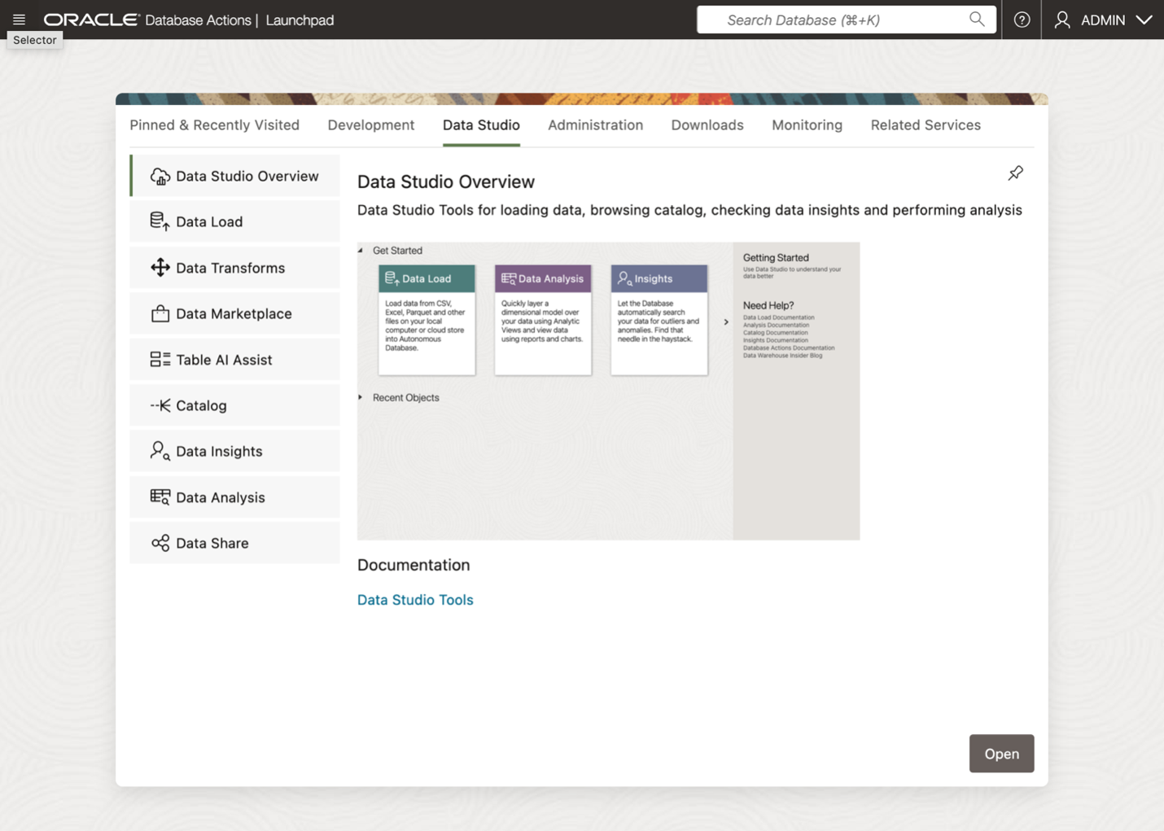

create-data-product-share-1.png

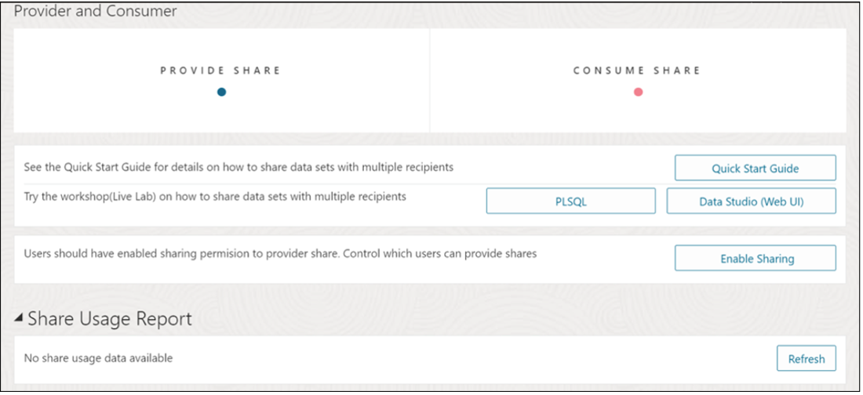

create-data-product-share-2.png

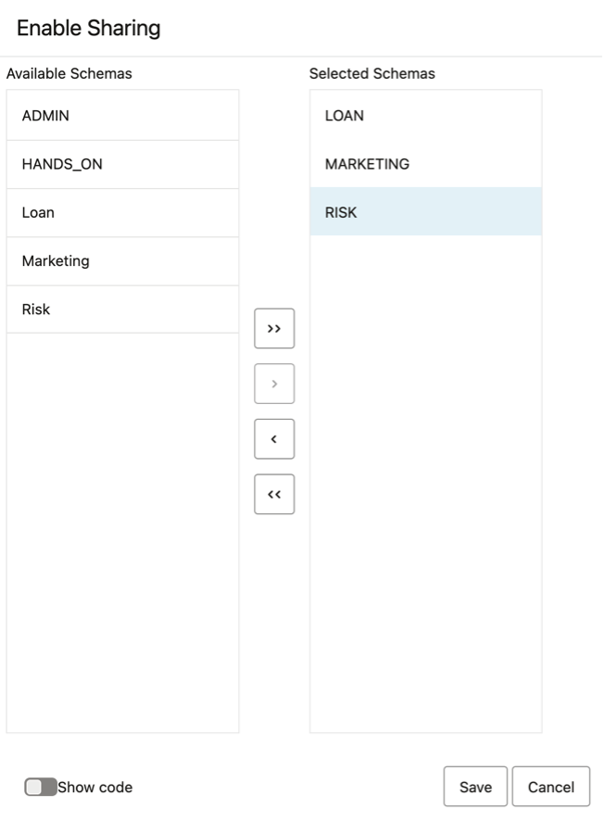

create-data-product-share-3.png

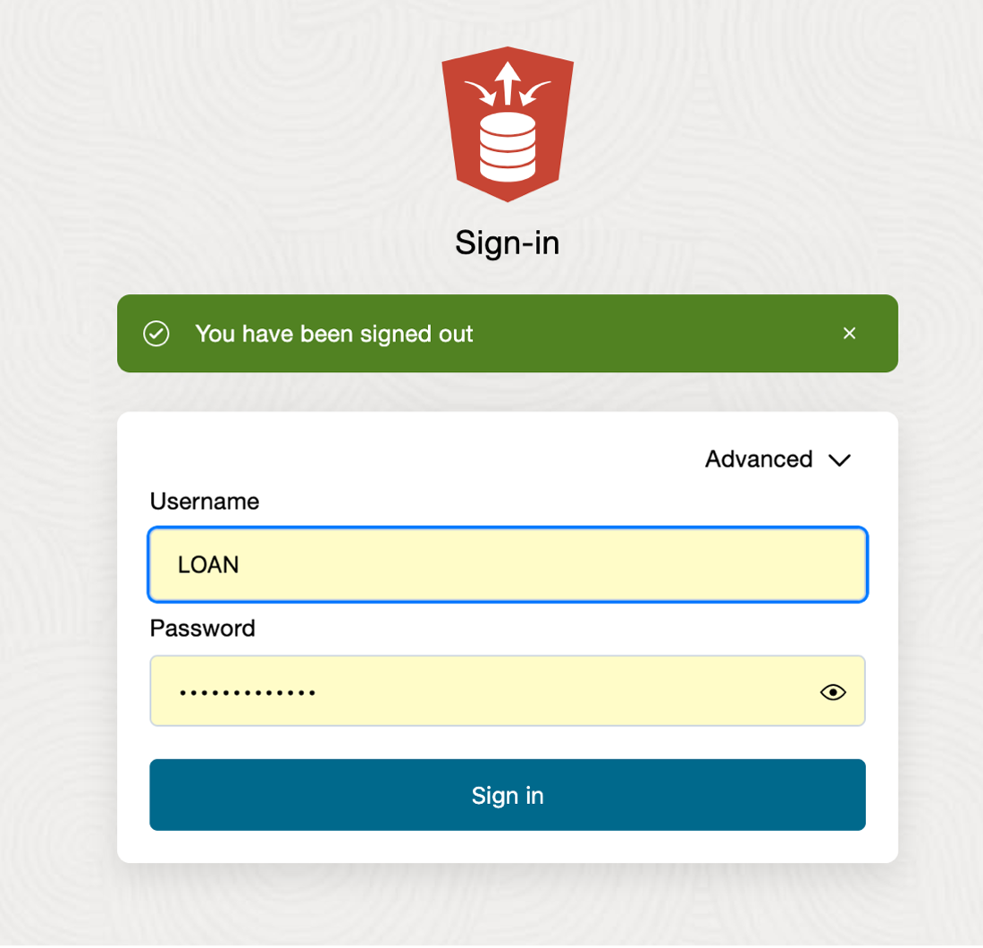

define-data-product-share-recipient-1.png

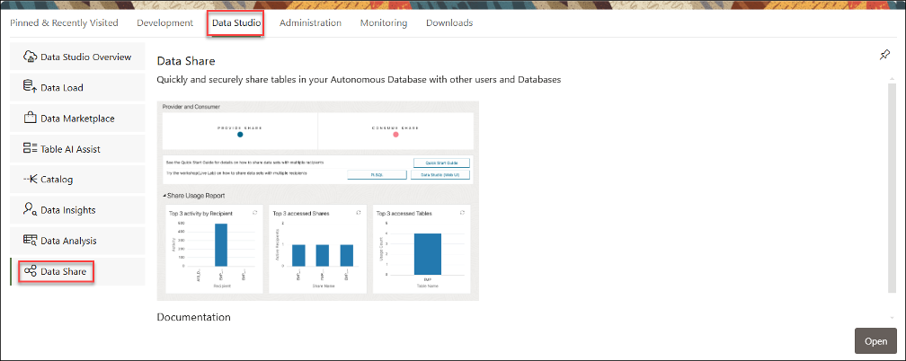

define-data-product-share-recipient-x.png

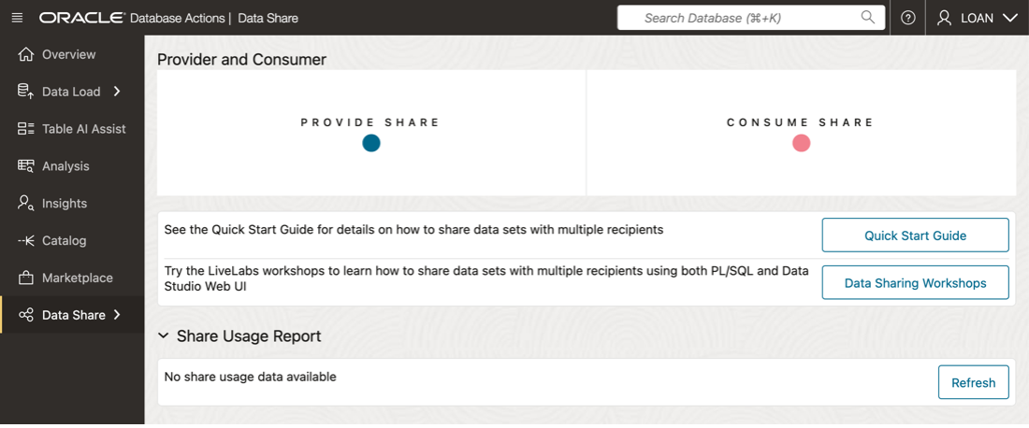

define-data-product-share-recipient-3.png

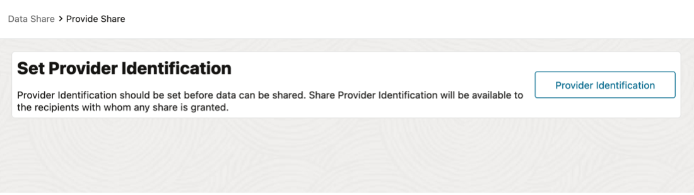

define-data-product-share-recipient-4.png

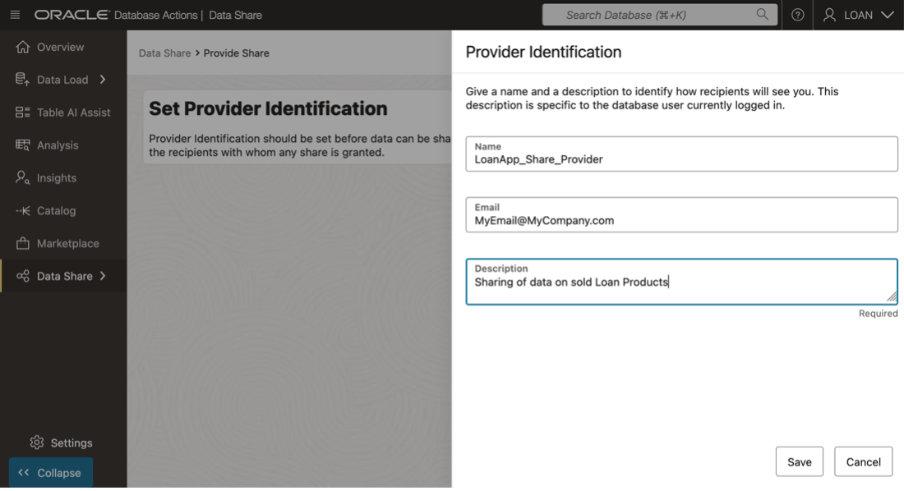

define-data-product-share-recipient-5.png

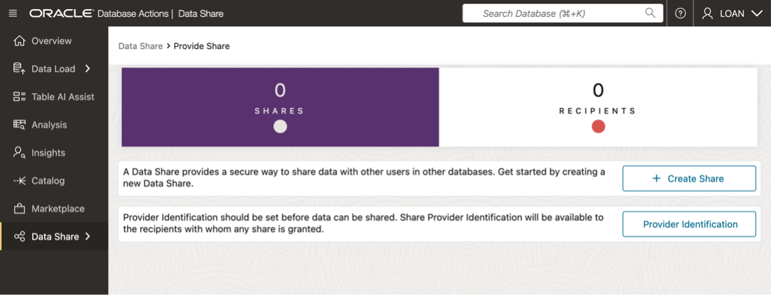

define-data-product-share-recipient-6.png

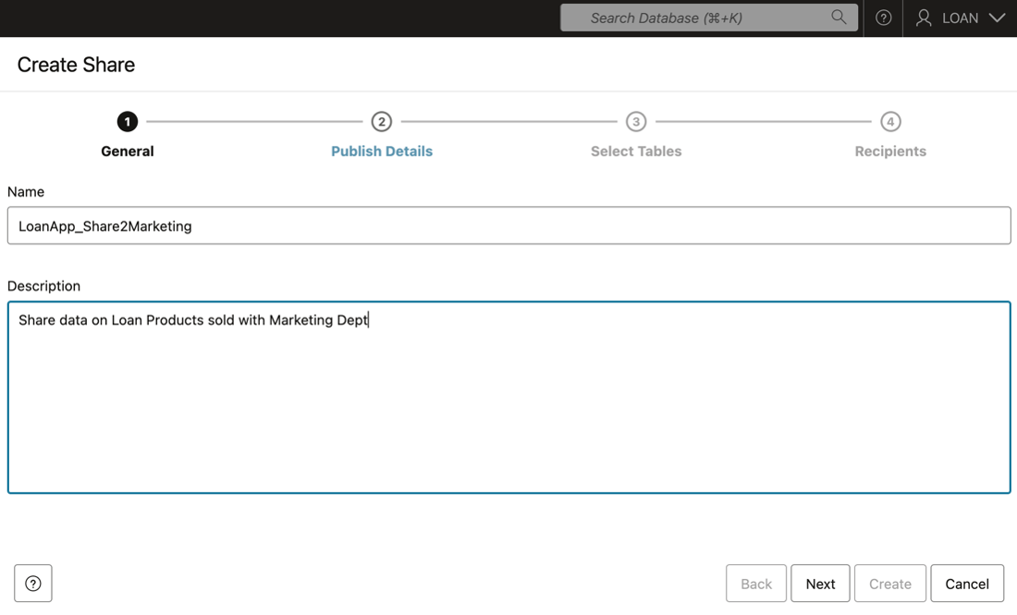

define-data-product-share-recipient-7.png

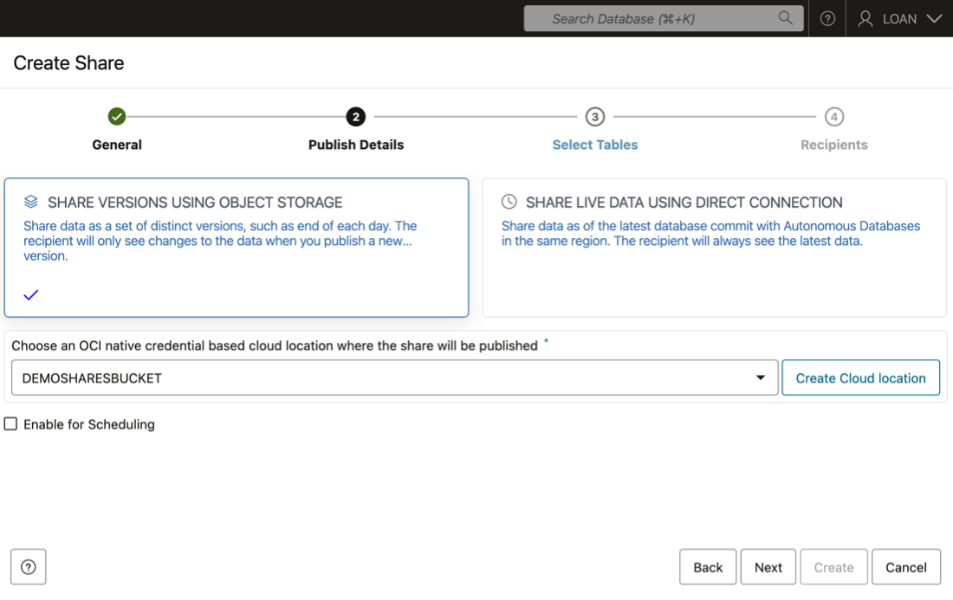

define-data-product-share-recipient-8.png

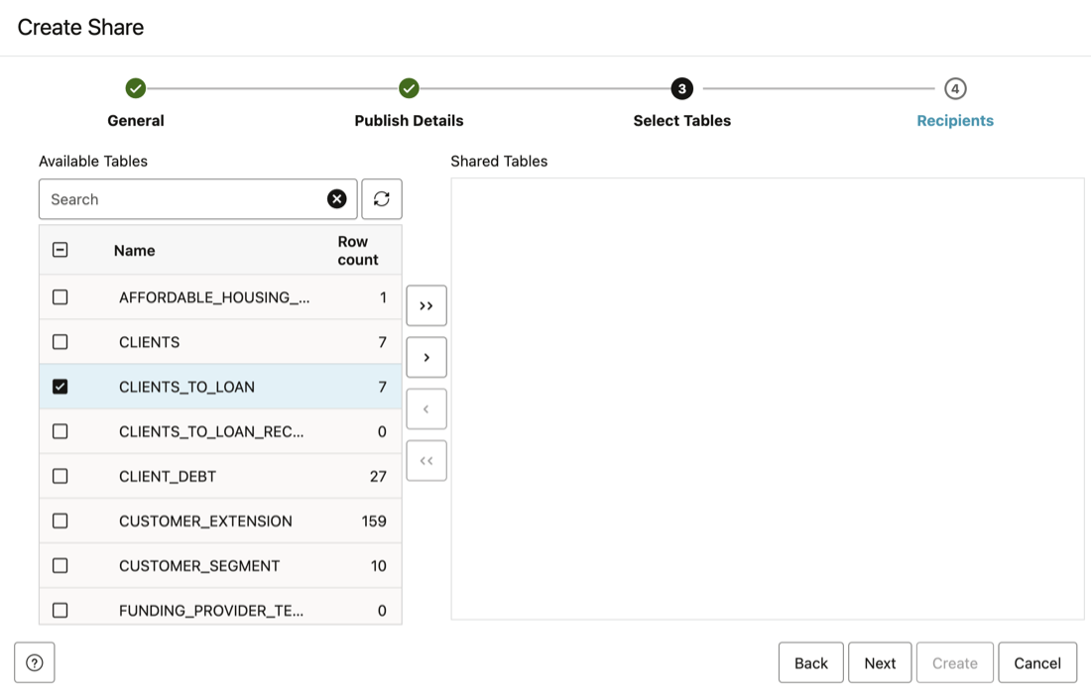

define-data-product-share-recipient-9.png

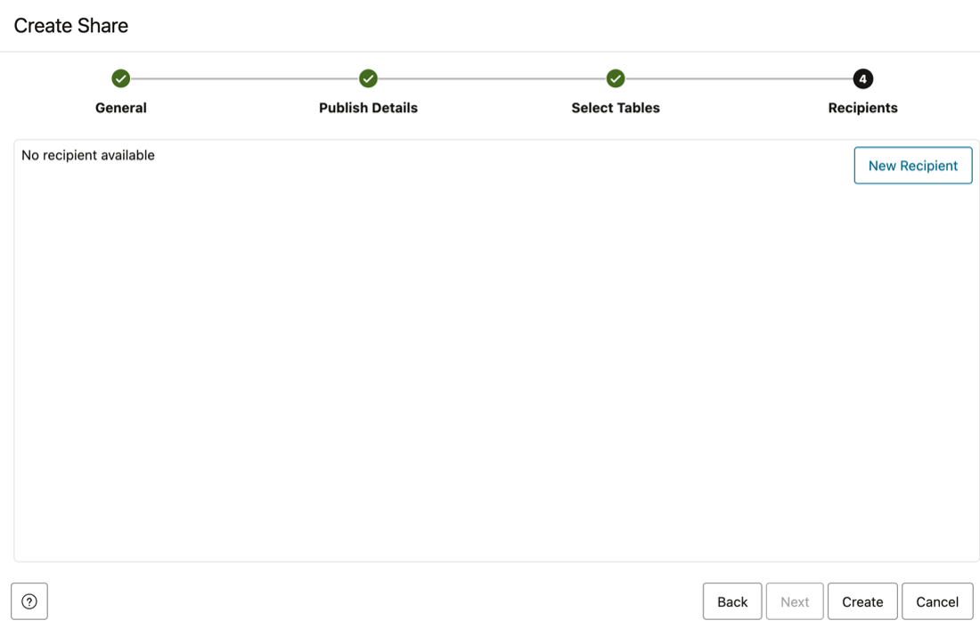

define-data-product-share-recipient-10.png

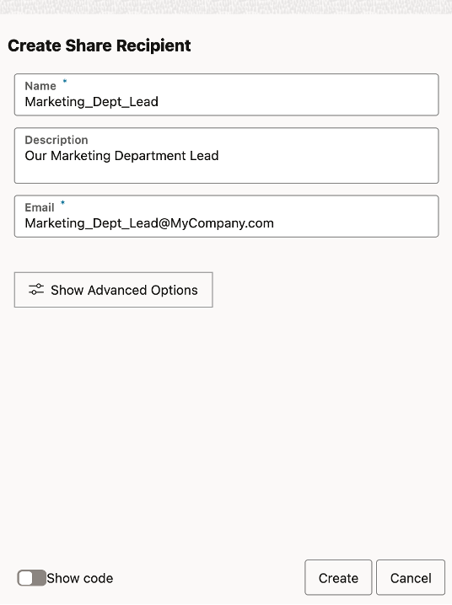

define-data-product-share-recipient-11.png

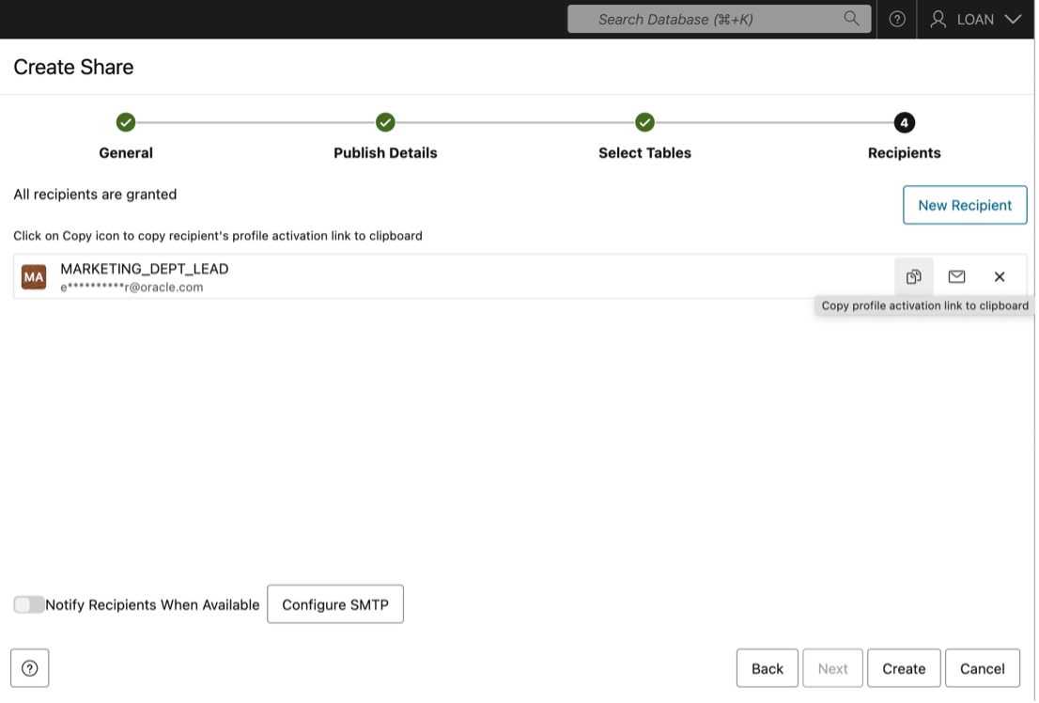

define-data-product-share-recipient-12.png

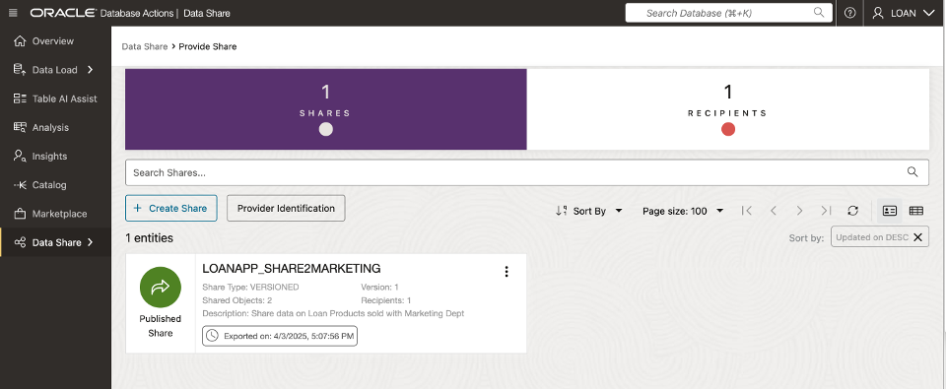

manage-data-product-share-1.png

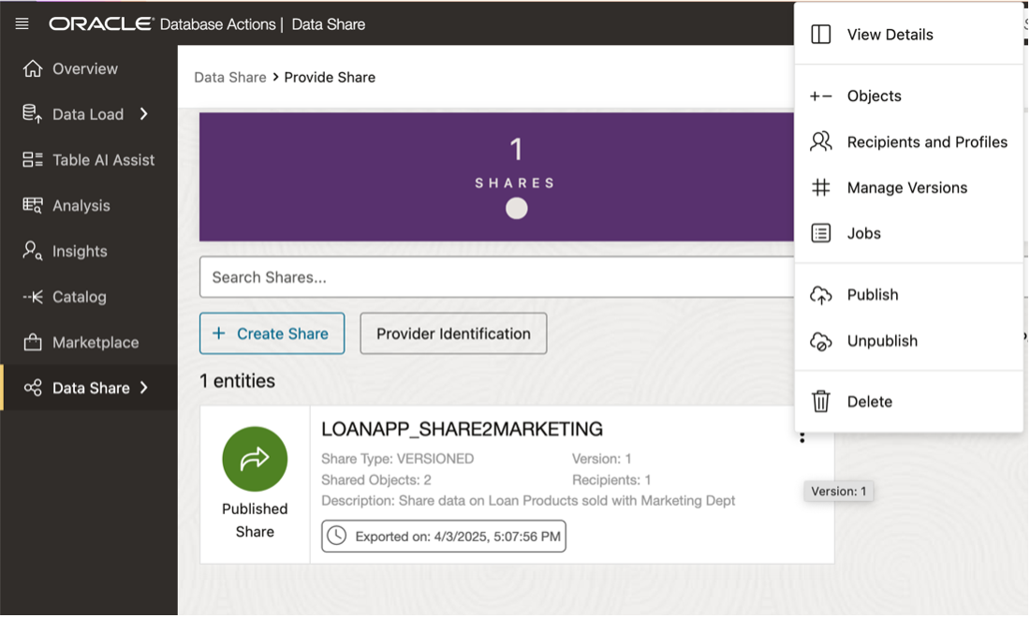

manage-data-product-share-2.png

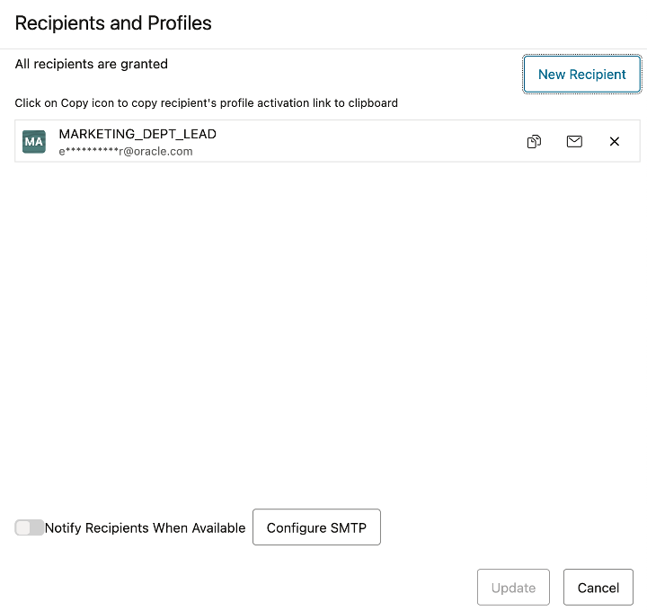

manage-data-product-share-3.png

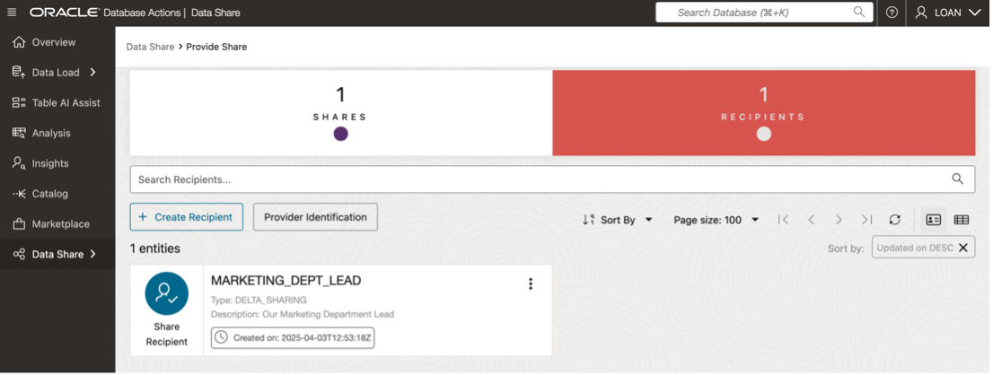

manage-data-product-share-4.png